Online Assembly Exercise

- Access the BV-BRC Assembly Service
- Go to BV-BRC Assembly Service website.
- Sign in or register for an account.
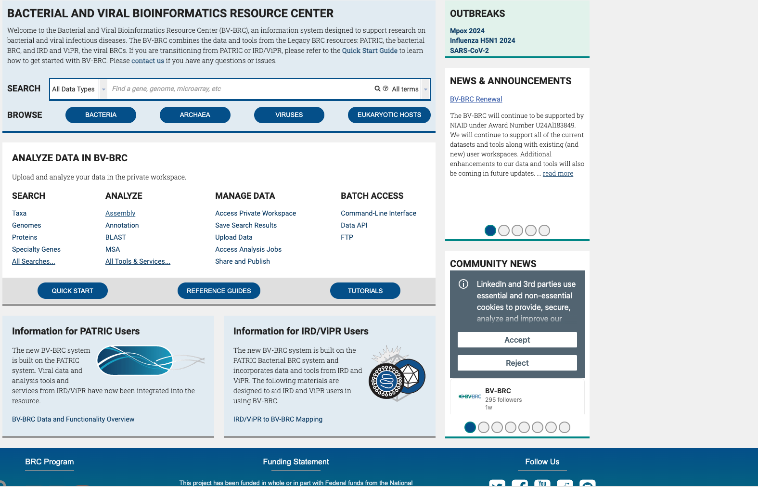
- Click on Assembly to go to the genome assembly service.

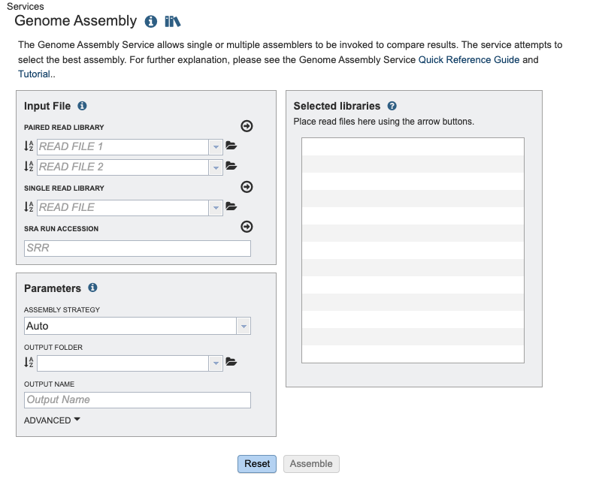

2. Upload Illumina Raw Reads
- Upload the Illumina fastq files.
- Run the assembly.
- Run the illumina-only assembly.

3. Upload ONT (Oxford Nanopore) Raw Reads
- Go back to the BV-BRC Assembly Service.
- Upload the ONT fastq file.
- Run the ONT-only assembly.

4. Hybrid Assembly: Combining Illumina and ONT Reads
- After running the individual assemblies, go back to the Assembly Service.
- Upload both the Illumina and ONT reads.
- Run the hybrid assembly.

5. Download Assembled Genomes
- Once all assemblies (Illumina, ONT, and Hybrid) are complete, download the assembled genome files from the results page.
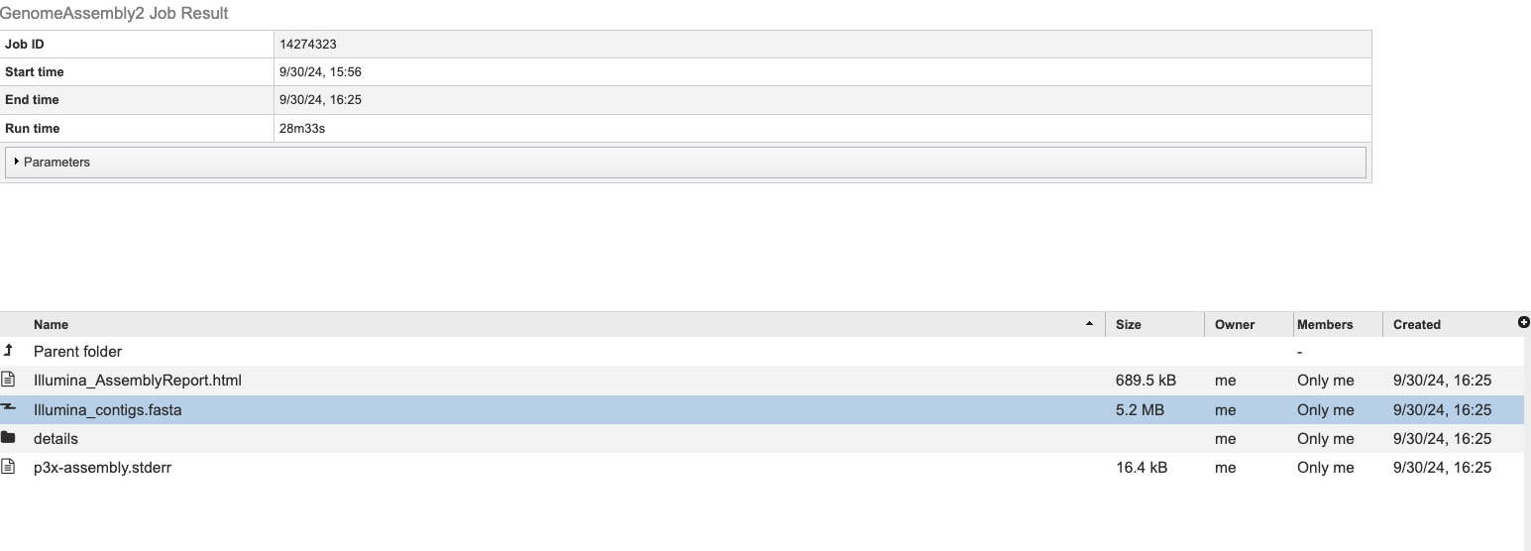
- These files will usually be in FASTA format.

6. Visualizing Assemblies with Bandage
- Download and install Bandage if not already installed: Bandage Download.
- Open Bandage on your computer.
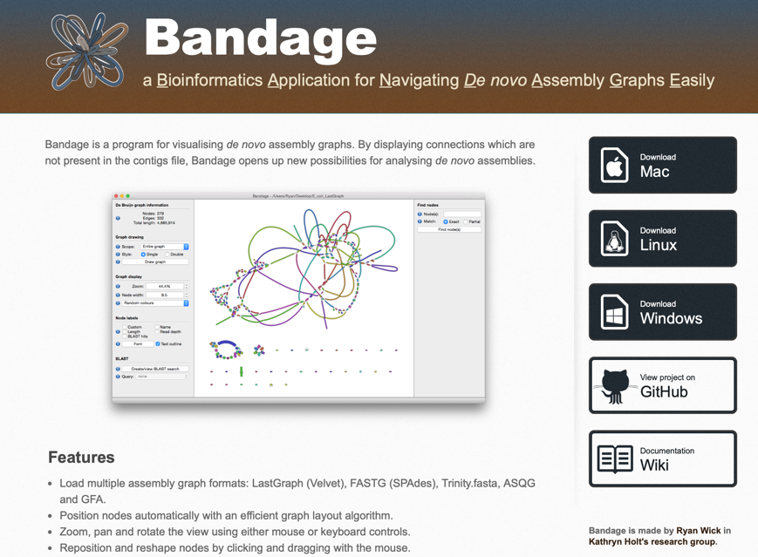

7. Viewing the Assemblies:
- Open the assembled genome files (FASTA files) in Bandage.
- Explore the assembly graph:
  - Examine contigs: Look at how contigs are connected.
  - Compare assembly quality: Note any differences in the assembly structure between Illumina-only, ONT-only, and Hybrid assemblies.
  - Look at the gaps, structural features, or possible misassemblies and see which assembly seems more complete or accurate.

8. Questions:
- Are there differences between the Illumina-only, ONT-only, and Hybrid assemblies?
- Do you see a lot of contigs or few contigs?
- Are there any plasmids?
- Did you notice any regions better resolved in one assembly type versus the other?
- How does the hybrid assembly improve or change the genome structure? Is it more contiguous than the individual assemblies?
- What challenges did you face when visualizing the genomes in Bandage? How do different assemblies affect the clarity of the graph?

